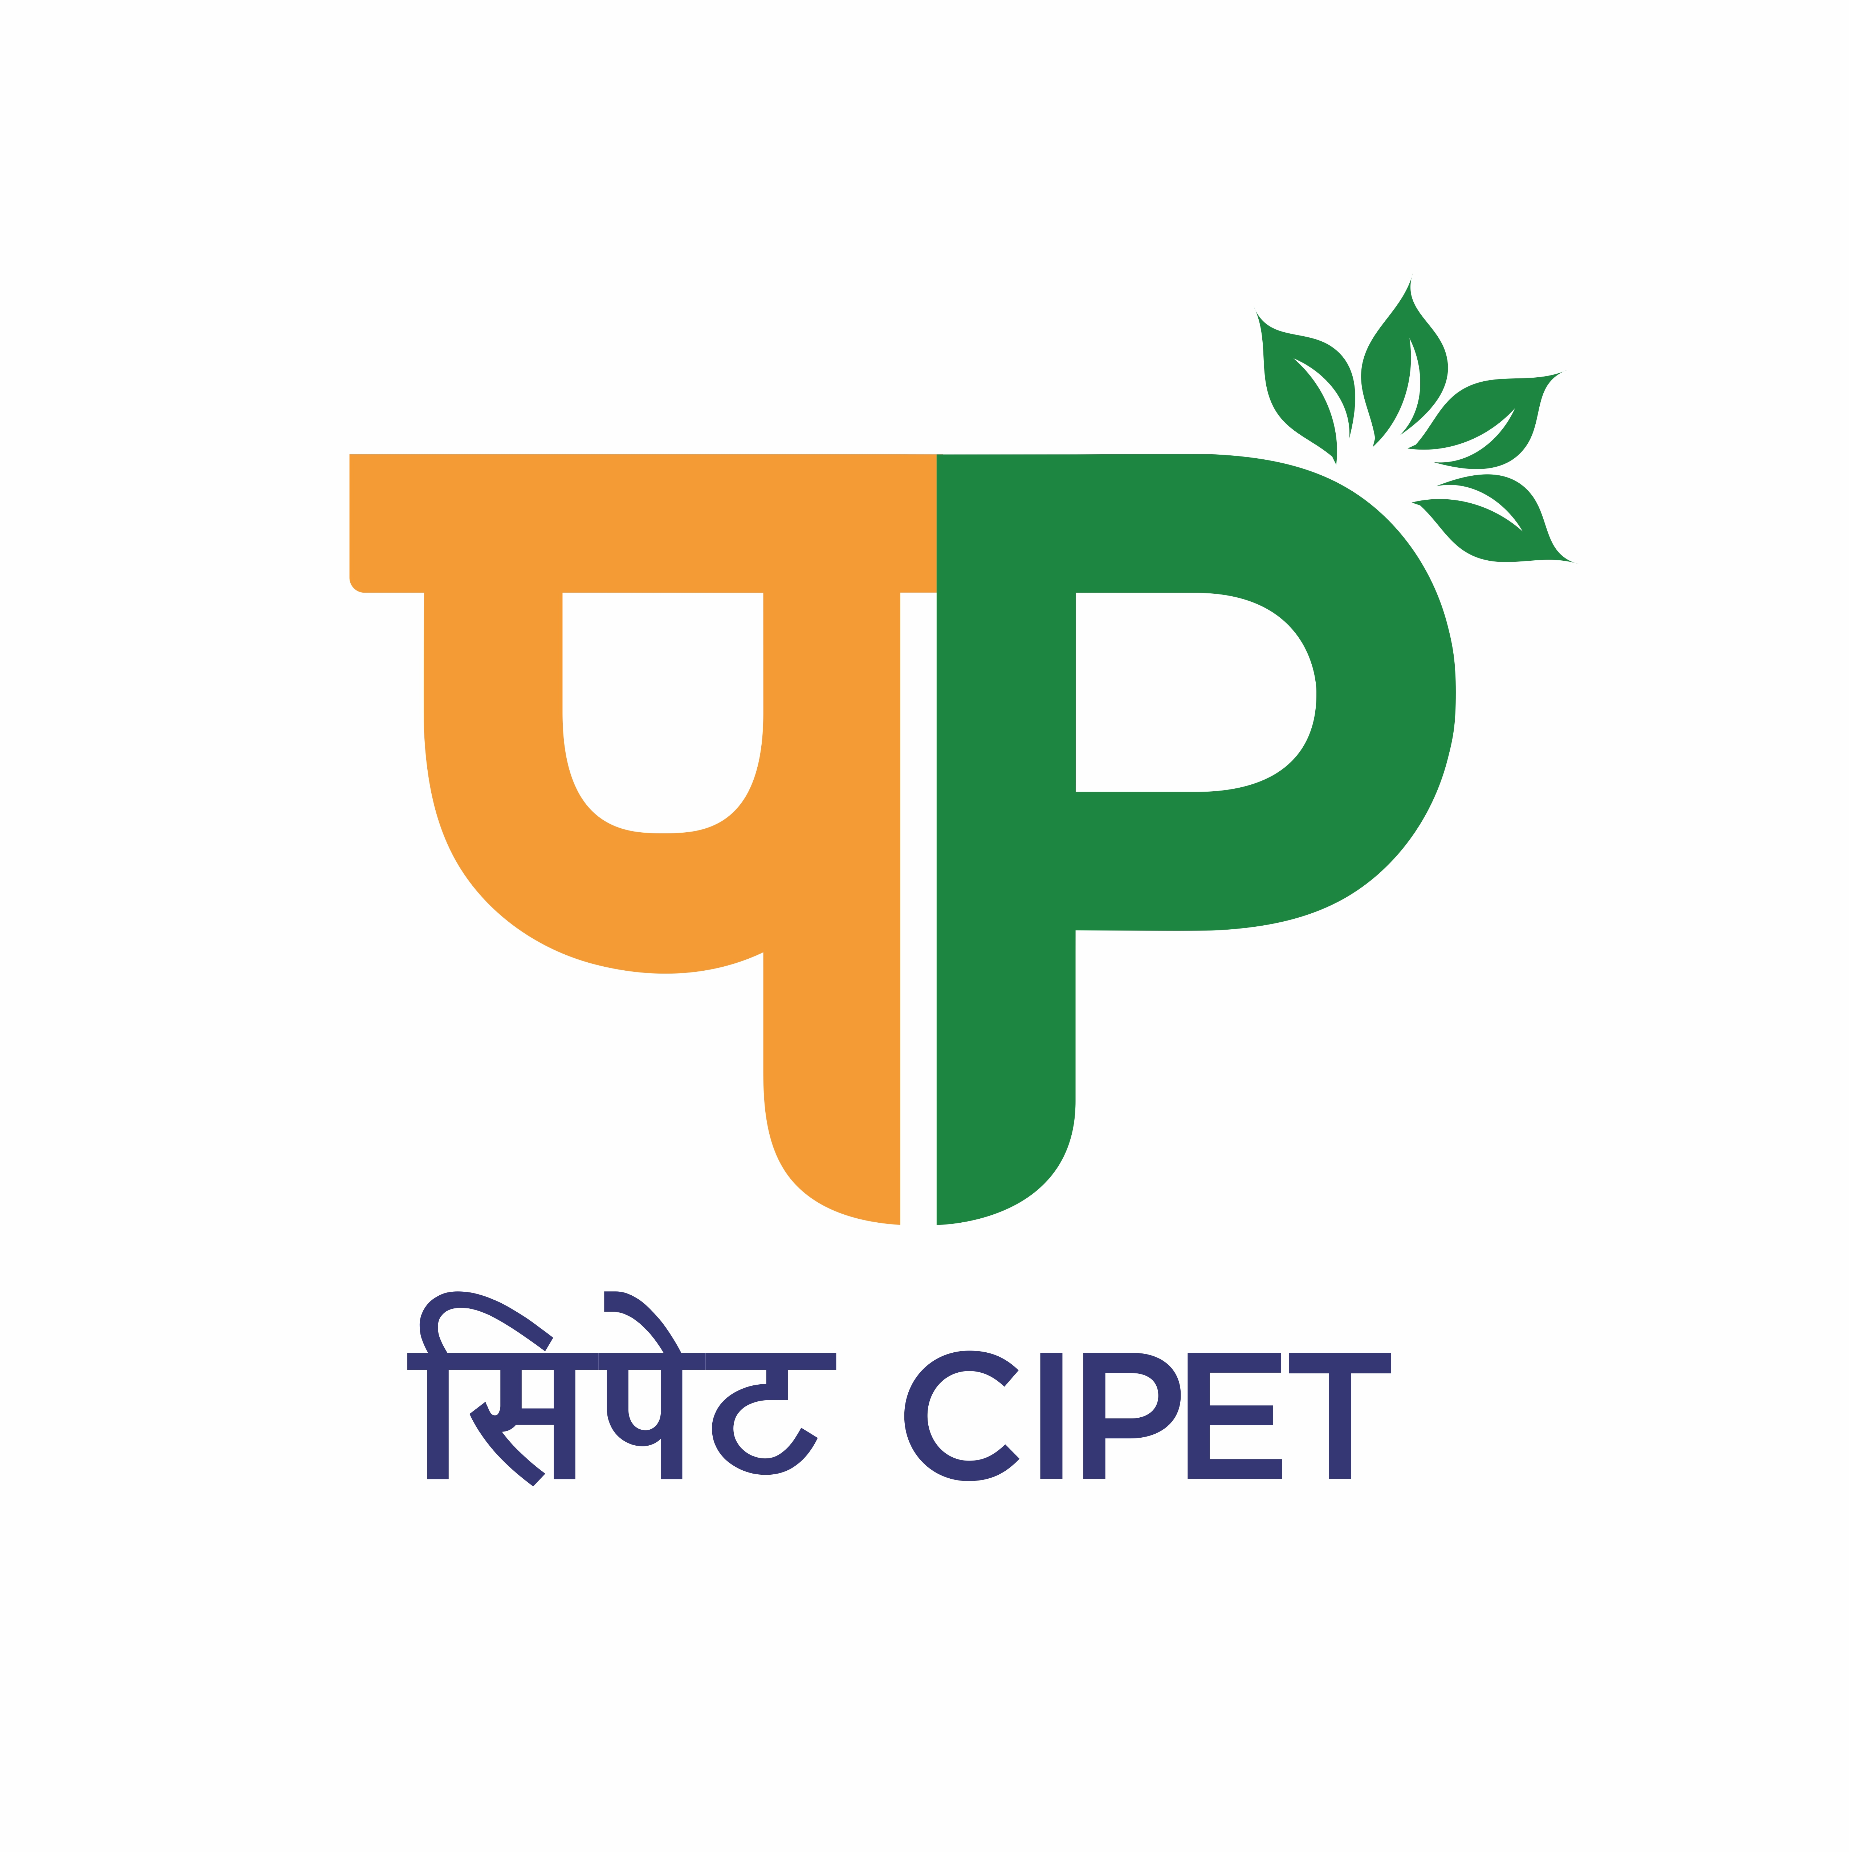 | APPLICATION FORM | 

Advt. Ref. No. CIPET: SARP-LARPM/Recruit.-GCE/2023-24/08 14.12.2023

Please tick () appropriate circle:-

PROJECT MANAGER
PROJECT ASSISTANT

Paste your Photograph
- Personal Details

Full Name (including surname; in block letters)

Father’s Name

Mother’s Name

Sex: Male Female Others

Marital Status : Single Married Others

Whether Physically Challenged: Yes / No.

If Yes, whether OH/HH/VH (Orthopedically/Hearing/Visually)

Date of Birth

Nationality Community: SC/ ST/ OBC/GEN

Permanent Home Address Correspondence Address (if different)

Telephone (Res) Telephone (Res)

Telephone (Mob) Telephone (Mob)

E-mail E-mail
- Academic Qualifications

Specialization:

Examinations Passed/ appeared in chronological order. Documentary evidence of known results should be sent with this form; only attested photocopies are acceptable

Qualification | Specialization | University/ College | Year of  Passing | % of marks/  Division
10th
+2/Intermediate
UG
PG
Others

Competitive Exam | Qualified | Marks/Rank | Year
CSIR-UGC NET | Yes/NO
GATE | Yes/NO
- PROJECT DETAILS (Describe in brief & continue on a separate sheet if necessary)

M.Sc/M.Tech/M.E./Ph.D

(Others)

4. Achievements: (Attach separate sheet if required)

5. Relevant Work Experience (Research/ Industrial etc) if any:
(Attach separate sheet if required)

Job Title;  Responsibilities;  Nature of work/training | Name of Organization | Full time or Part-time | From |  | To
Job Title;  Responsibilities;  Nature of work/training | Name of Organization | Full time or Part-time | Month | Year | Month | Year
Current post :
Other posts:

6. Relevant Publications/ Patents/ Presentations/Computer Proficiency
Please provide any other relevant information to support your application, continue on a separate sheet if necessary.

7. Knowledge on high end Characterization equipments related plastics/polymer Technology.

8. Name and address of Referee (s)

Referee 1 Referee 2

Telephone Telephone

E-mail E-mail

9. Declaration

I declare that the entries made in the columns of this proforma are correct and true to the best of my knowledge and nothing has been either concealed or misrepresented by me. I understand that CIPET reserves the right to withdraw any offer or cancel a registration made on the basis of information which proves to be false or misleading.

Applicant’s Full Signature Date

