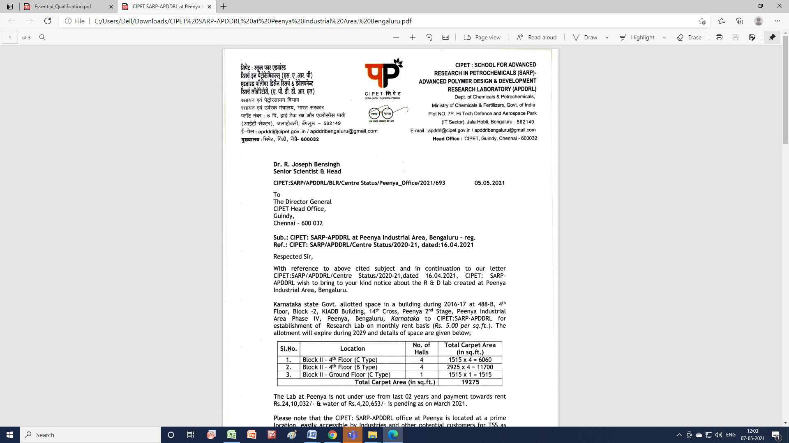 | Advanced Polymer Design and Development Research Laboratory (APDDRL)  School for Advanced Research in Petrochemicals (SARP)  Central Institute of Petrochemicals Engineering & Technology (CIPET)  Department of Chemicals and Petrochemicals  Ministry of Chemicals and Fertilisers, Govt. of India  Passport size color photo  Plot No. 7P, Hi-tech Defense and Aerospace Park  Jalahobli, Devanahalli, Bengaluru North, Karnataka – 562149  E-mail: apddrlbengaluru@gmail.com / apddrl@cipet.gov.in;  Website: www.cipet.gov.in

Application FOR Junior Research Fellow / Project Associate - I
Application for JRF/PA-1 under DST Sponsored Project entitled”Technology for Aberration free Polymer Bi-aspheric Lens for Indirect Ophthalmology”

1. | Full Name (including Surname) | :
2. | Date of Birth | :
3. | Gender | : | Male / Female
4. | Marital Status | : | Married / Unmarried / Divorced / Widow
5. | Nationality | :
6. | Father's / Spouse’s Name | :
7. a) | Postal Address for correspondence | :
7. b) | Permanent Address | :
7. c) | Contact Number | :
7.d ) | Email ID | :

8. Academic Qualifications:
Give particulars in a chronological order starting with High School

Sl. No. | Degree | Subject/  Specialization | Division/ Grade | % of Marks | Year | University/Board

9. Whether Qualified GATE / NET / SLET: Yes / No.
(If Yes, give the scores)
Percentile: ________________ Valid upto: ______________

10. Professional / Research Employment details: (Give particulars in descending chronological
order starting with the present post).
Sl. No | Employer | Post held | Stipend/Month | Period of Employment  (Month/Year)
Sl. No | Employer |  | Stipend/Month | From | To

11. Academic Project Details (UG / PG & Others):

12. Area of specialization (to be filled in on the basis of Academic Qualification and experience relevant to the post applied):

13. Material Characterization / Analysis & Results Interpretation Skills:

14. Software Skills

15. If you claim Research Experience furnish details on:
- Sponsored Research Projects – Completed / In progress.

- Sponsored Consultancy Projects – Completed /In progress.

- Research paper / review paper publications. [Enclose list of publications in Journals with impact factor (mention co-authors(s), Title, Journals, Months & Year, Page Nos.) along with copy of reprints]

- No. of research papers presented in International Conferences {(Enclose list of papers presented in Conferences (mention co-authors(s), Title, Conference, Month & Year, Page Nos.)}

- Patents/Technology transfer if any:

14. Current Stipend per Month : ______________________

15. Willing to Register for Ph.D.: YES / NO

Declaration

I declare that the entries made in the columns of this proforma are correct and true to the best of my knowledge and nothing has been either concealed or misrepresented by me.

Place: Signature
Date :

