CENTRAL INSTITUTE OF PETROCHEMICALS ENGINEERING & TECHNOLOGY (CIPET)
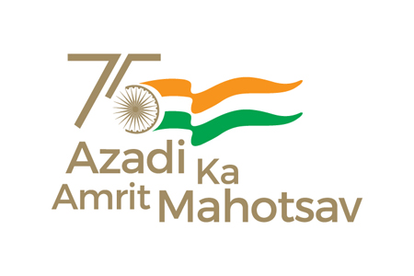
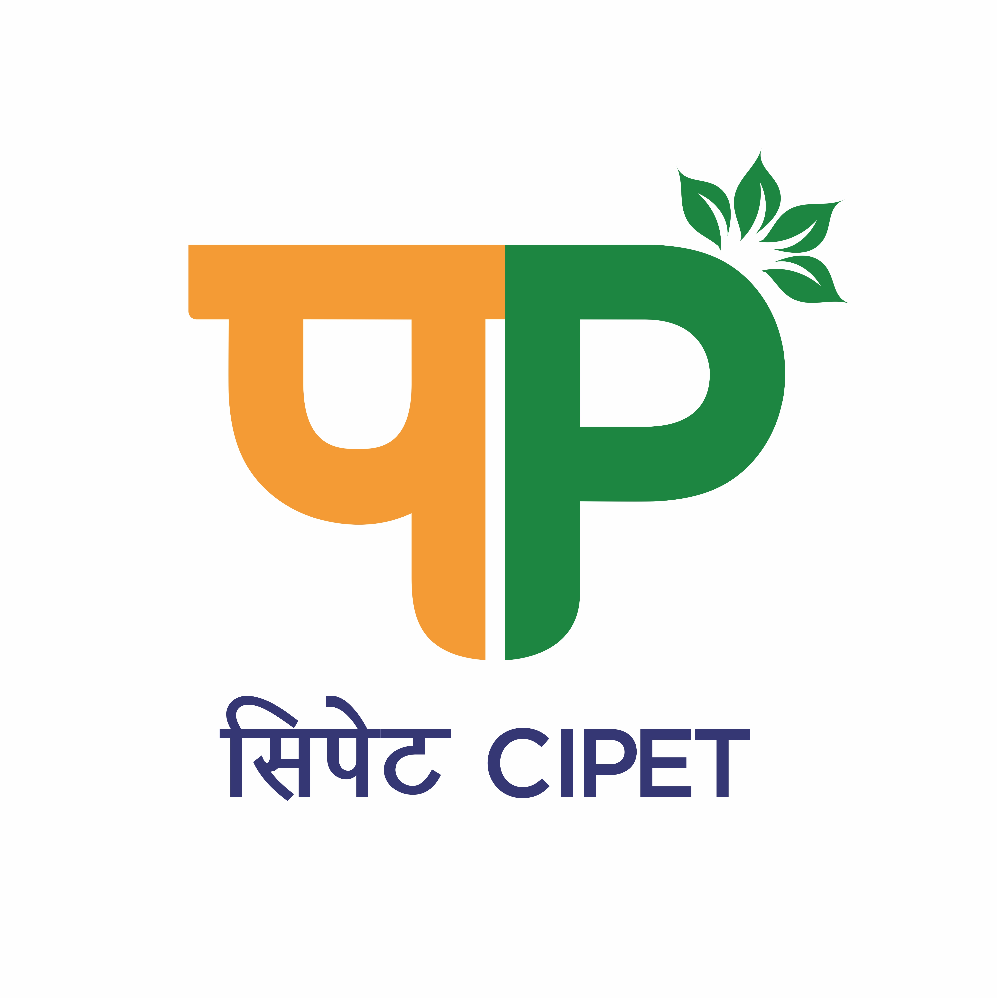
SCHOOL FOR ADVANCED RESEARCH IN PETROCHEMICALS (SARP)
सिपेट:एसएआरपी-एलएआरपीएम, भुवनेश्वर
(Department of Chemicals & Petrochemicals,

Ministry of Chemicals & Fertilizers, Govt. of India)
B-25, C.N.I. Complex, Patia, Bhubaneswar – 751 024 (Odisha)
Tel: 0674-2740173/2742852, Fax: 0674-2740463
Email: larpm@cipet.gov.in, Website: www.cipet.gov.in

CIPET:SARP-LARPM/Recruit-Spon.Proj./2023-24/03 08.08.2023
CALL FOR APPLICATIONS FOR RESEARCH PERSONNEL
CIPET: SARP-LARPM, Bhubaneswar invites young and dynamic Research Personnels for the following positions to work under various sponsored projects :-
Name of the Post(s) | No. of Positions | Qualification | Fellowship
Research Associate-I | 01 | Full time Ph.D in Polymer Science, Chemistry, Materials Science, Physics, Nanotechnology from a recognized University or equivalent with relevant research experience in the area of Additive Manufacturing with Computer Aided Design Softwares, Sensors, Polymer Blends, Alloys, Composites, Polymer Processing, Piezoelectric, Bio-Medical applications.. | As per Institute norms/guidelines
Business Manager | 01 | - Full time MBA in Marketing / Finance from a recognized University.  - Minimum 05 years of post qualification experience in handling project related or similar work in the field of Finance and Marketing.  Essential Skill Sets:  - Experience in Project Management and Planning.  - Should have excellent Oral and Written communication skills.  - Should possess excellent skills in Marketing, Leadership, Problem Solving, Revenue Generation and Creativity. | As per Institute norms/guidelines
Junior Research Fellow(JRF)*/ Project Associate-I | 03 | Full time M.Sc. in Polymer Science, Physics, Chemistry, Materials Science & Engineering, Bio-Polymer Science  Or  Full time M.E/M.Tech. in Plastics Engineering, Polymer Nanotechnology  *GATE, NET Qualification mandatory. | As per Institute norms/guidelines

How to Apply: The candidates having the desired qualification & experience may apply with all relevant documents to “The Incharge-Administration, CIPET:SARP-LARPM, B-25, CNI Complex, Patia, Bhubaneswar-751024, Odisha” by speedpost/courier only on or before 31.08.2023 (Thursday) till 05.30 P.M. No other means of application shall be entertained.
Duration of Project : The position is purely temporary and initially only for a period of 01 (one) year but extendable if work is found satisfactory on year-to-year basis till the completion of the Project.

The Application Form, essential qualification & other details can be downloaded from www.cipet.gov.in.
CIPET:SARP-LARPM, Bhubaneswar reserves the right to increase/decrease/cancel any or all the posts without assigning any reasons thereof.

Incharge-Administration

Terms and Conditions:

- The contract is purely temporary and initially only for a period of 01(one) year but extendable if work is found satisfactory on year-to-year basis till the completion of the Project.

- The Candidate have to fully devote their time for the project work and are not allowed to join any other course (Part/ Full time).

- Upper Age Limit as on 31.08.2023 for the post of Business Manager shall be 40 years and for Junior Research Fellow(JRF)/Project Associate-I shall be 35 years respectively.

- Age relaxation for SC/ST/OBC and women candidates will be extended as per DST rules and 230(17) of GFR 2017 concerning reservation of SC/ST/OBC, if applicable.

- Complete applications in the prescribed format should reach the below mentioned address on or before 31.08.2023(Thursday) till 05.30 P.M :

The Incharge-Administration
CIPET: SARP-LARPM
B-25, CNI Complex, Patia,
Bhubaneswar – 751024, Odisha

- Selection will be made purely as per the Institute guidelines.

- No TA/DA will be paid for either attending the interview or while joining the project.

- Original documents of Certificates / Degrees / Mark sheets / Age-Proof / and other Testimonials should be produced at the time of Interview.

- Shortlisted candidates will be called for the Written Test/Interview either in person/online and the date of Interview will be intimated via e-mail only. No other communication in this regard will be entertained.

- If the Applicant fails to submit the required documents/incomplete applications shall be rejected.

- If any candidate is found guilty of providing false information in due course after selection/joining, then necessary action shall be taken against the candidate and he/she shall have to refund all the payments made to him/her during the said tenure.

Incharge-Administration

