CENTRAL INSTITUTE OF PETROCHEMICALS ENGINEERING & TECHNOLOGY (CIPET)

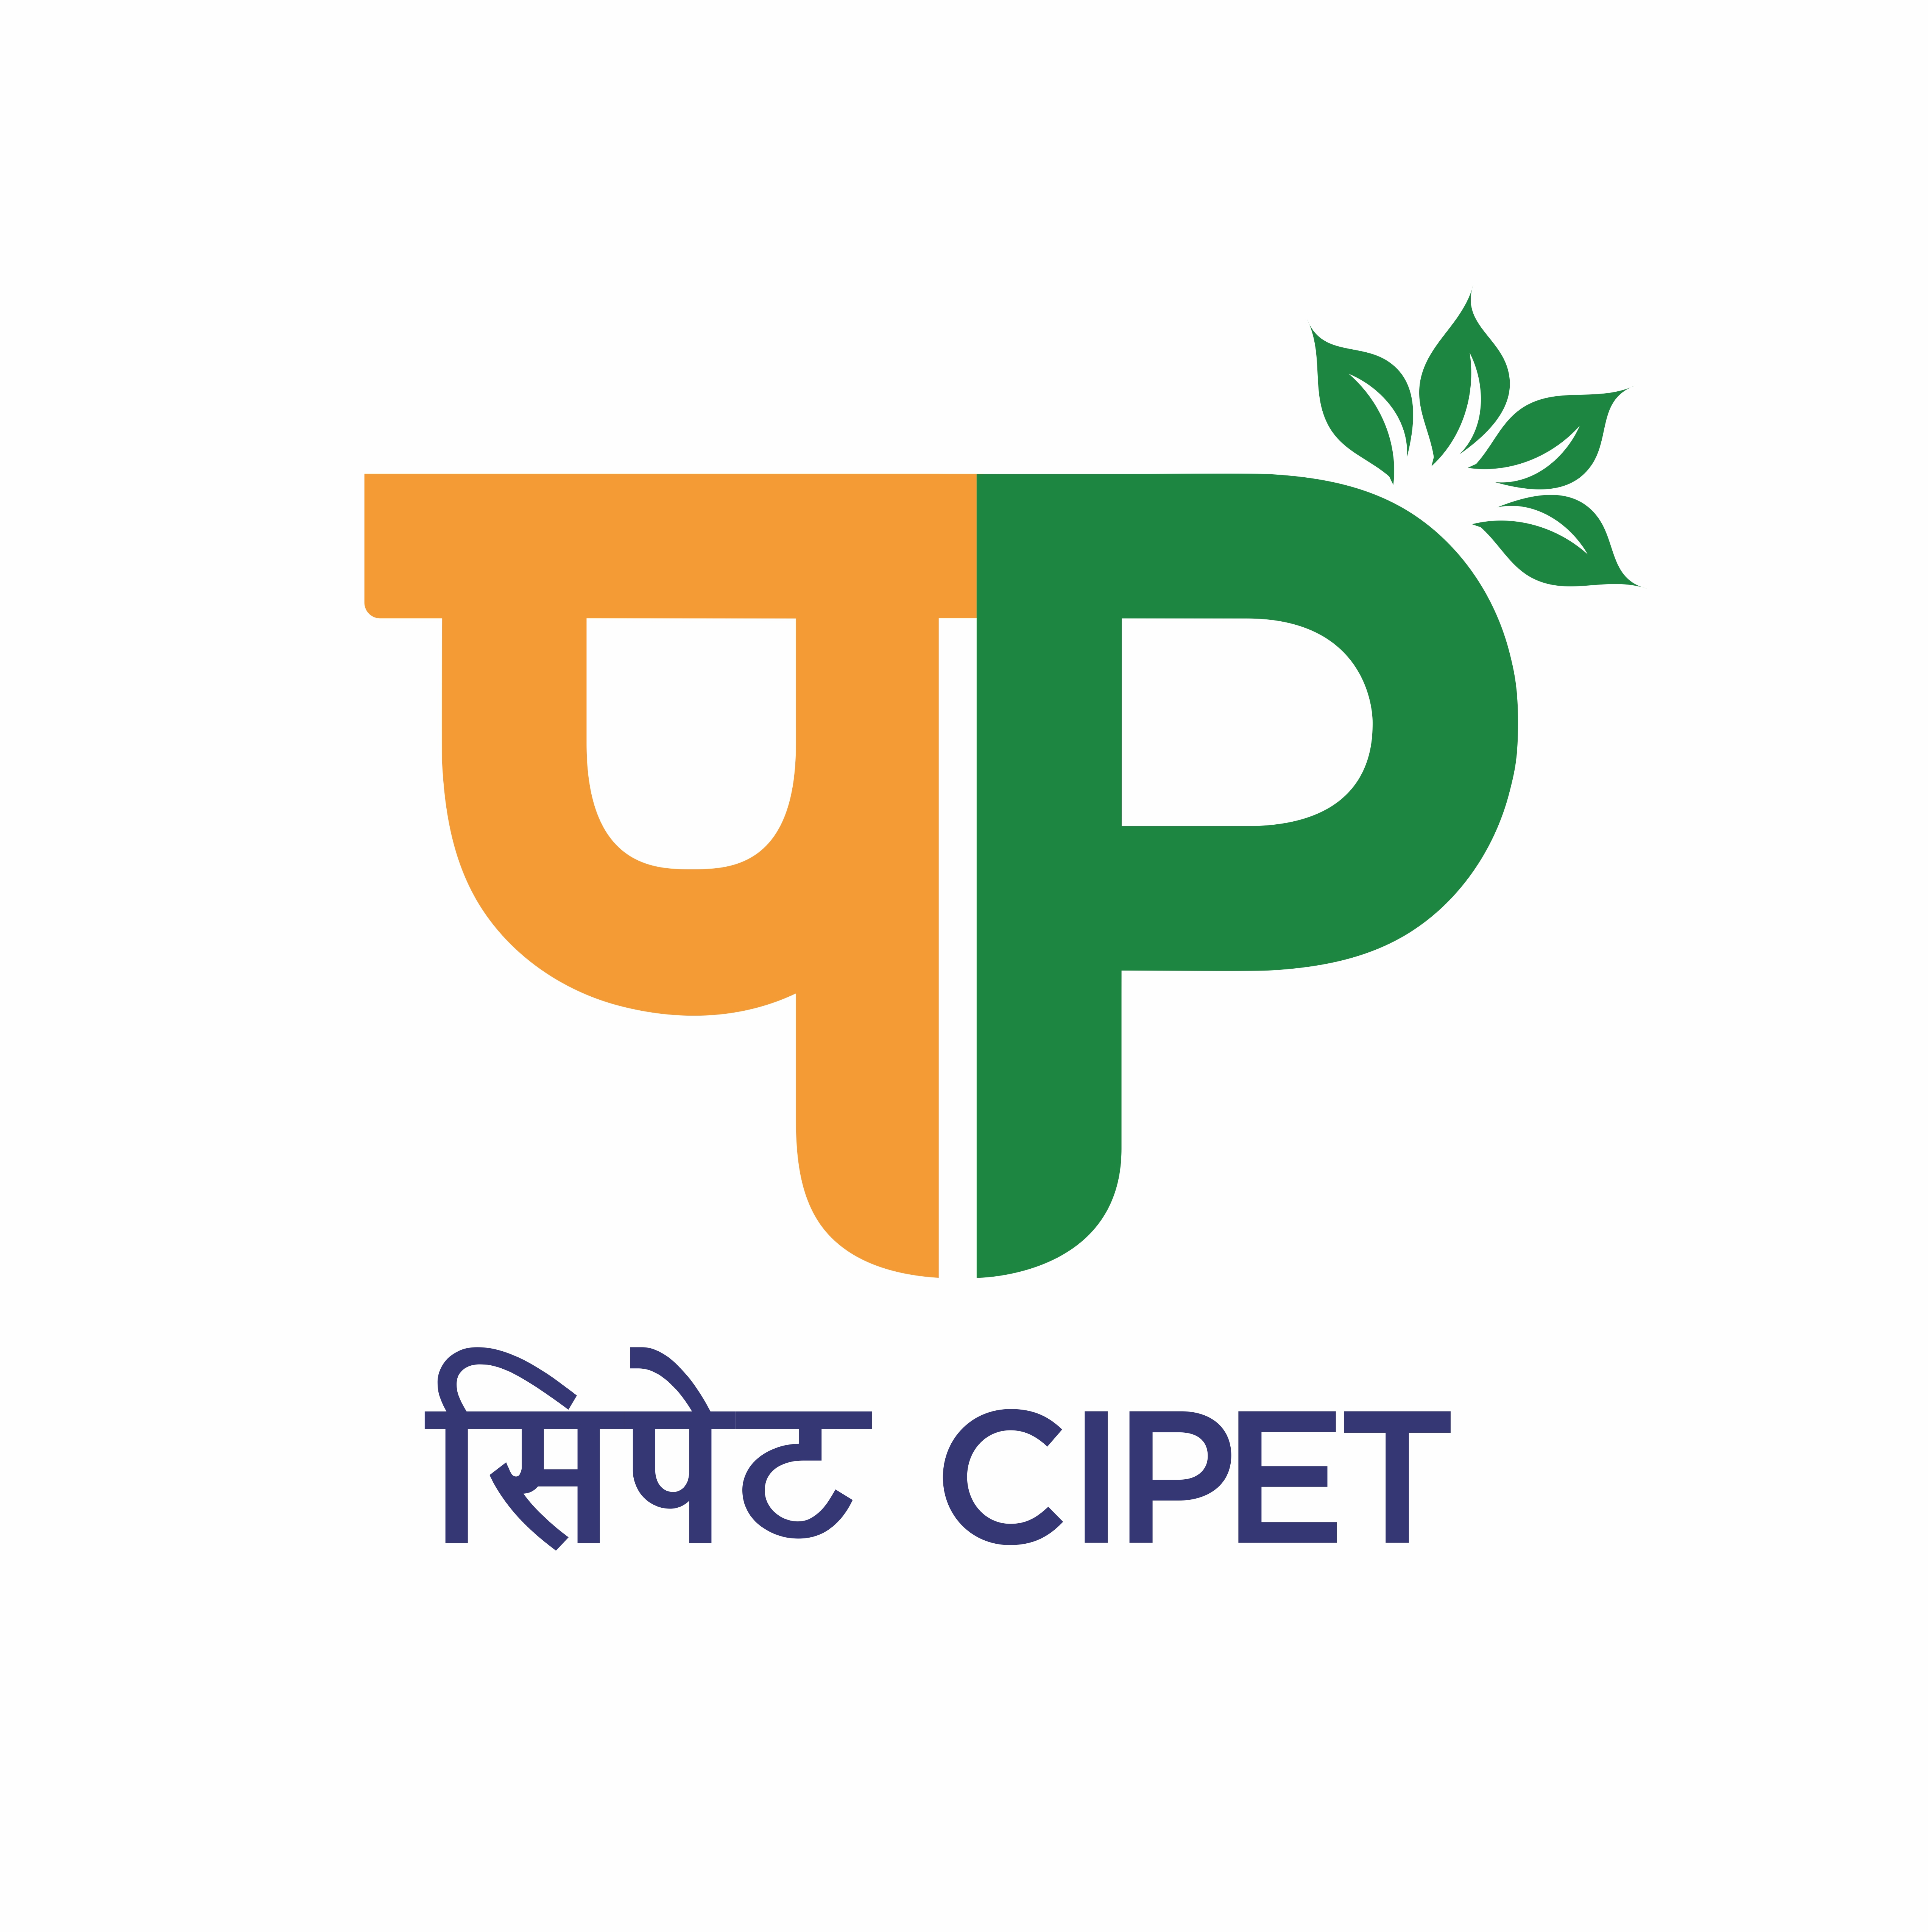
SCHOOL FOR ADVANCED RESEARCH IN PETROCHEMICALS (SARP)
सिपेट:एसएआरपी-एलएआरपीएम, भुवनेश्वर
(Department of Chemicals & Petrochemicals,

Ministry of Chemicals & Fertilizers, Govt. of India)
B-25, C.N.I. Complex, Patia, Bhubaneswar – 751 024 (Odisha)
Tel: 0674-2740173/2742852, Fax: 0674-2740463
Email: larpm@cipet.gov.in, Website: www.cipet.gov.in

CIPET:SARP-LARPM/Recruit-Spon.Proj./2023-24/02 28.06.2023
WALK-IN-INTERVIEW FOR RESEARCH PERSONNELS

CIPET: SARP-LARPM, Bhubaneswar invites young and dynamic Research Personnels for the following positions to work under various sponsored projects :-

Name of the Post(s) | No. of Positions | Qualification | Fellowship
Project Fellow (Laboratory Management) | 02 | B.E/B.Tech. in Plastics Engineering/Manufacturing Engineering / Mechanical Engineering or its equivalent with 03 years post qualification experience  Essential Skill Sets:  - Candidates having knowledge of Additive Manufacturing using various techniques (FDM, Binder Jet, SLA, SLS etc.)  - Should have good oral and written communication skills.  - Strategic thinking, Research Skill on Project Management, Creativity, Knowledge of standups/startups in Incubation cell.  - Experience in maintaining of NABL ISO/IEC 17025-2017 Documentation procedures.  - Competency in Hands-on experience in handling sophisticated equipment’s/machineries in Polymer Processing and Product Designing. | As per Institute norms/guidelines
Project Fellow (Technical) | 04 | Master of Science with 03 years of post qualification experience in relevant field.  Or  Bachelor of Science with PGD-PPT & 05 years of post qualification experience in the relevant field.  Essential Skill Sets:  - Should have strong understanding of Laboratory techniques and procedures.  - Familiar with wide range of scientific instruments related to Polymer Testing techniques including Biodegradation, Microscopes, Spectrometers, Chromatography Systems, Analysers etc.  - Able to collect, analyse and interpret data generated by Laboratory experiments.  - Record-keeping and documentation as per ISO/IEC-17025-2017, ISO-9001, LIMS etc.  - Able to Troubleshoot problems in scientific equipments. | As per Institute norms/guidelines

How to Apply: The candidates having the desired qualification & experience may walk-in-interview with all relevant original documents with one set of photocopy and duly filled in application form on –24.07.2023(Monday) at 11.00 A.M at CIPET:SARP-LARPM, B-25, C.N.I. Complex, Patia, Bhubaneswar – 751 024, Odisha.
Duration of Project : The position is purely temporary and initially only for a period of 01 (one) year but extendable if work is found satisfactory on year-to-year basis till the completion of the Project.

The Application Form, essential qualification & other details can be downloaded from www.cipet.gov.in.
CIPET:SARP-LARPM, Bhubaneswar reserves the right to increase/decrease/cancel any or all the posts without assigning any reasons thereof.

Incharge-Administration

Terms and Conditions:

- The contract is purely temporary and initially only for a period of 01(one) year but extendable if work is found satisfactory on year-to-year basis till the completion of the Project.

- The Candidate have to fully devote their time for the project work and are not allowed to join any other course (Part/ Full time).

- Age relaxation for SC/ST/OBC and women candidates will be extended as per DST rules and 230(17) of GFR 2017 concerning reservation of SC/ST/OBC, if applicable.

- Selection will be made purely as per the Institute guidelines.

- No TA/DA will be paid for either attending the interview or while joining the project.

- Original documents of Certificates / Degrees / Mark sheets / Age-Proof / and other Testimonials should be produced at the time of Walk-in-Interview.

- If the Applicant fails to submit the required documents, the application shall be rejected.

- If any false information is provided by the candidate(s) and is found guilty, necessary action will be taken and the candidate has to refund all the payments made to him/her.

Incharge-Administration

